# Assignment #1

45

The following is a form generated by a local mechanic when he performs work on an automobile.

|  |  |  |  |  |  |  |  |
| --- | --- | --- | --- | --- | --- | --- | --- |
| **Work Order #** | | | 12345 | |  | | |
| **Date** | | | January 12, 2010 | |
| **Customer ID** | | | 0012 | |
| **Customer Name** | | | Bob Jones | |
| **Mechanic** | | | Handy Manny | |  | | |
|  | | | | | | | |
| **Quantity** | **Unit** | **Item Code** | | **Description** | | **Unit Price** | **Total** |
| 8 | hrs | LABOUR | | Replaced Widget | | 50.00 | 400.00 |
| 1 | ea | WIDGET | | 10” Purple Wingnut | | 35.00 | 35.00 |
| 5 | ft | DUCT | | Grey Duct Tape | | 75.00 | 375.00 |
|  |  |  | |  | |  |  |
|  | | | | | | **Subtotal** | 810.00 |
| **Tax** | 105.30 |
| **Balance Due** | 915.30 |

10

1. List the categories or “entities” that are needed to store all the information from this form and, for each entity, list the fields that will hold the specific information.

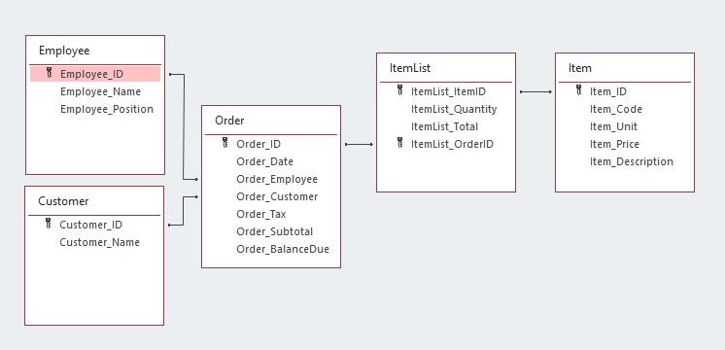

1. For each field named above, briefly describe if it would or would not be a good candidate for a primary key and why.

15

Entity: Customer

|  |  |  |
| --- | --- | --- |
| Field | Y/N? | Why? |
| Customer_ID | Y | It would be a good candidate for primary key because it is a unique number automatically generated |
| Customer_Name | N | It wouldn't be a good candidate for primary key because there might be equal names |

Entity: Employee

|  |  |  |
| --- | --- | --- |
| Field | Y/N? | Why? |
| Employee_ID | Y | It would be a good candidate for primary key because it is a unique number automatically generated |
| Employee_Name | N | It wouldn't be a good candidate for primary key because there might be equal names |
| Employee_Position | N | It would not be a good candidate for primary key because many employees have the same position |

Entity: Item

|  |  |  |
| --- | --- | --- |
| Field | Y/N? | Why? |
| Item_ID | Y | It would be a good candidate for primary key because it is a unique number automatically generated |
| Item_Description | N | It would not be a good candidate for primary key because there may be description of equal items |
| Item_Code | N | It would not be a good candidate for primary key because at some point it can become difficult to find a letter code that makes sense of the item name and is still available |
| Item_Unit | N | It would not be a good candidate for primary key because many items have the same unit |
| Item_Price | N | It would not be a good candidate for primary key because many items have the same price |

Entity: ItemList

|  |  |  |
| --- | --- | --- |
| Field | Y/N? | Why? |
| ItemList_ItemID | Y | It would be a good candidate for primary key because it is a unique number derived from another entity, but this field needs to be combined with the ItemList_OrderID field to be truly unique. |
| ItemList_Quantity | N | It wouldn't be a good candidate for primary key because many item lists have the same amount |
| ItemList_Total | N | It wouldn't be a good candidate for primary key because many item lists have the same total |
| ItemList_OrderID | Y | It would be a good candidate for primary key because it is a unique number derived from another entity, but this field needs to be combined with the ItemList_ItemID field to be truly unique. |

Entity: Order

|  |  |  |
| --- | --- | --- |
| Field | Y/N? | Why? |
| Order_ID | Y | It would be a good candidate for primary key because it is a unique number automatically generated |
| Order_Date | N | It wouldn't be a good candidate for primary key because many orders are generated on the same date. |
| Order_Customer | N | It would not be a good candidate for primary key because a customer may have many orders |
| Order_Employee | N | It wouldn't be a good candidate for primary key because an employee has too many orders |
| Order_Subtotal | N | It wouldn't be a good candidate for primary key because many orders have the same subtotal |
| Order_Tax | N | It wouldn't be a good candidate for primary key because many orders have the same tax |
| Order_BalanceDue | N | It wouldn't be a good candidate for primary key because many orders have the same balance due |

A company’s IT department needs to catalog the computer assets in order to better maintain their systems. They want to be able to enter information about standard hardware (e.g. a computer, printer or monitor) and who is using the hardware. They also want to track when a user requests a technician to service their hardware, what the request or complaint was about and what the technician during the service call.

10

1. List what entities and what corresponding fields are required to maintain this information.   
     
   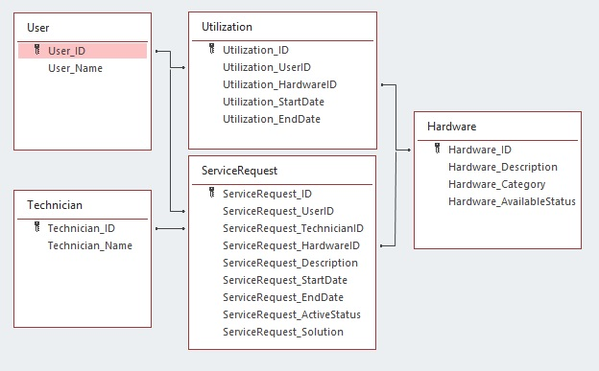
2. Describe the relationships between the different entities identified above by listing the entities and if they require a foreign key from another entity. If they do require a foreign key, include the name of the entity from where the foreign key is derived.  
     
   ex.   
   *One* ***Tree*** *has many* ***Leaves****, so* ***Leaf*** *would need a foreign key**from* ***Tree****.*

10

Entity: User

|  |  |  |  |  |  |
| --- | --- | --- | --- | --- | --- |
| Field | Primary Key | Foreign Key | Relationship | Type | Origin |
| User_ID | Yes | No |  |  |  |
| User_Name | No | No |  |  |  |

Entity: Utilization

|  |  |  |  |  |  |
| --- | --- | --- | --- | --- | --- |
| Field | Primary Key | Foreign Key | Relationship | Type | Origin |
| Utilization_ID | Yes | No |  |  |  |
| Utilization_UserID | No | Yes | User-Utilization | One-to-many | User_ID |
| Utilization_HardwareID | No | Yes | Hardware-Utilization | One-to-many | Hardware_ID |
| Utilization_StartDate | No | No |  |  |  |
| Utilization_EndDate | No | No |  |  |  |

Entity: Hardware

|  |  |  |  |  |  |
| --- | --- | --- | --- | --- | --- |
| Field | Primary Key | Foreign Key | Relationship | Type | Origin |
| Hardware_ID | Yes | No |  |  |  |
| Hardware_Description | No | No |  |  |  |
| Hardware_Category | No | No |  |  |  |
| Hardware_AvaliableStatus | No | No |  |  |  |

Entity: ServiceRequest

|  |  |  |  |  |  |
| --- | --- | --- | --- | --- | --- |
| Field | Primary Key | Foreign Key | Relationship | Type | Origin |
| ServiceRequest_ID | Yes | No |  |  |  |
| ServiceRequest_UserID | No | Yes | User- ServiceRequest | One-to-many | User_ID |
| ServiceRequest_TechnicianID | No | Yes | Technician- ServiceRequest | One-to-many | Technician_ID |
| ServiceRequest_HardwareID | No | Yes | Hardware- ServiceRequest | One-to-many | Hardware_ID |
| ServiceRequest_Description | No | No |  |  |  |
| ServiceRequest_StartDate | No | No |  |  |  |
| ServiceRequest_EndDate | No | No |  |  |  |
| ServiceRequest_ActiveStatus | No | No |  |  |  |
| ServiceRequest_Solution | No | No |  |  |  |

Entity: Technician

|  |  |  |  |  |  |
| --- | --- | --- | --- | --- | --- |
| Field | Primary Key | Foreign Key | Relationship | Type | Origin |
| Technician_ID | Yes | No |  |  |  |
| Technician_Name | No | No |  |  |  |